**DAILY ONLINE ACTIVITIES SUMMARY**

|  |  |  |  |  |  |  |  |  |
| --- | --- | --- | --- | --- | --- | --- | --- | --- |
| **Date:** | **27-05-2020** | | | | | **Name:** | **Pavana P** | |
| **Sem & Sec** | **6A** | | | | | **USN:** | **4AL17CS057** | |
| **Online Test Summary** | | | | | | | | |
| **Subject** | | **SSCD** | | | | | | |
| **Max. Marks** | | **30** | | **Score** | | | **20** | |
| **Certification Course Summary** | | | | | | | | |
| **Course** | **How to create Chatbots.** | | | | | | | |
| **Certificate Provider** | | | Cognitive classes | | **Duration** | | | 4 hours |
| **Coding Challenges** | | | | | | | | |
| **Problem Statement:**  1.Write a C Program to Generate First N Triangular Numbers (Where N is read from the Keyboard) | | | | | | | | |
| **Status: Completed** | | | | | | | | |
| **Uploaded the report in Github** | | | | | **YES** | | | |
| **If yes Repository name** | | | | | **DAILY STATUS** | | | |
| **Uploaded the report in slack** | | | | | **YES** | | | |

.

**Online Test :**

Subject:-SSCD

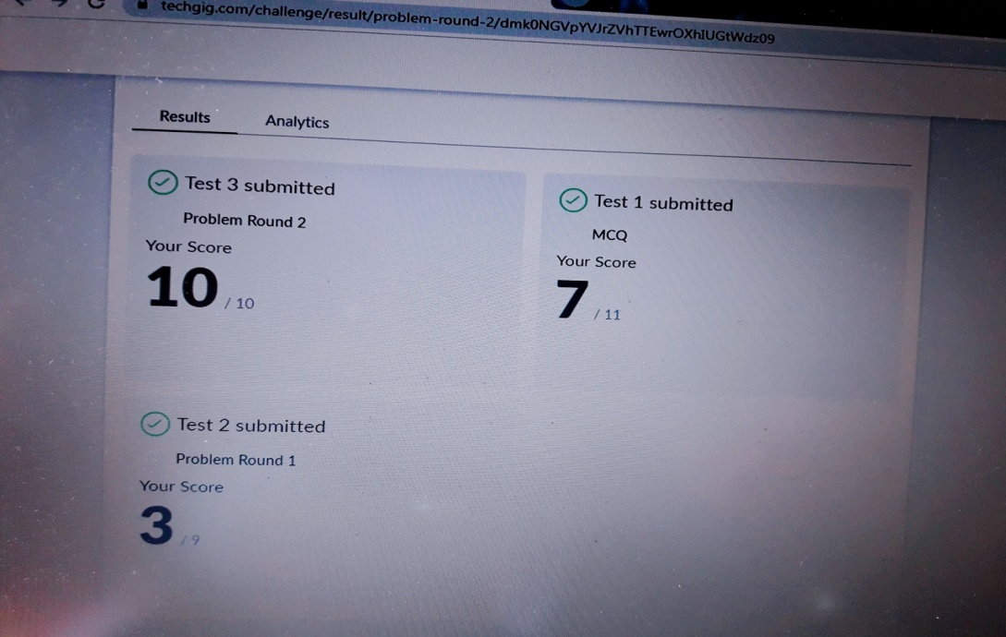

**Certification Course Details:**

**How to create Chatbots :**

Today I have completed these topics:

1.Building up friendly chatbots.

2.Implementing the dialogue.

3.Definr domain specific intents.

4.Deploying a chatbot.

.

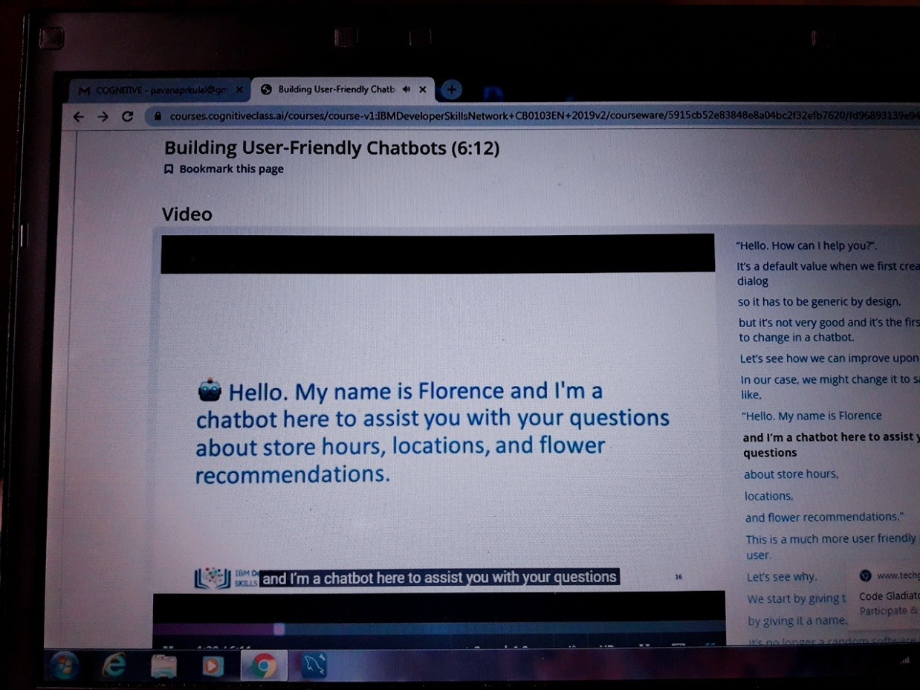

**Coding Challenges Details:**

**https://github.com/pavana-p-kulal/DAILY-STATUS/tree/master/27-5-20/Online%20Coding**